**SURVEY ON GUIDED AND UNGUIDED MEDIA OF COMPUTER NETWORKS**

---------------------------------------------------------------------------------------------------------

*Jeevan Koshy*

*1740256*

---------------------------------------------------------------------------------------------------------

The medium in which electromagnetic signals travel amongst different communicating devices such as computers, routers and the like in the form of electromagnetic signals are known as transmission media. The transmission medium is basically a physical path and a channel where data is sent from one place to another. This transmission media can be divided into 2 separate classifications such as –

* Guided media
* Unguided media

***Guided media***

The electromagnetic signals travel through a physical medium. Guided media is also known as wired communication or bounded transmission media. It has the ability to provide directions to the signals for travelling and the signals being transmitted are directed and confined in a narrow pathway using physical links. The different categories of guided media are –

* Twisted pair cable = Has 2 conductor wires wounded around each other surrounded by an insulating material.   
  It is cheap, ease to install and has a high-speed capacity.

Unfortunately, it is prone to external inference, lower capacity and performance and allows only short distance communication.

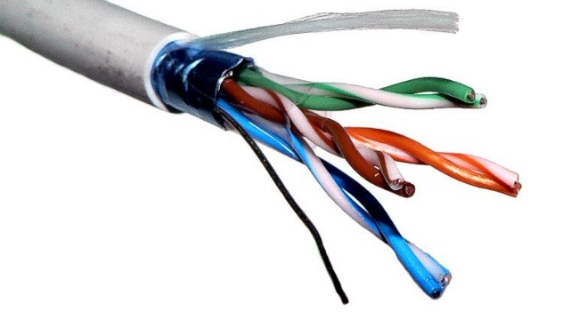

*Twisted pair cable*

* Coaxial cable = Contains a copper central core conductor enclosed in an insulating sheath thereby further encased in an outer metallic braid which serves as protection against noise and completes the circuit. This cable contains signals of higher frequency than the twisted pair cable. Information is transmitted in two modes –

1. Baseband mode
2. Broadband mode

The coaxial cable has higher bandwidth, better noise immunity, it is easy to install and expand and at the same time it is also inexpensive.   
Unfortunately, a single cable failure can disrupt the entire network.

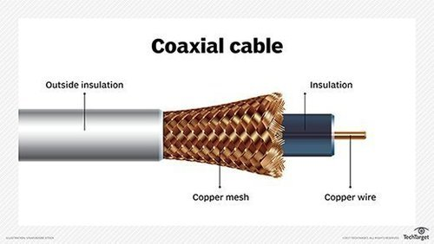

* Fibre optic cable = It is either made of glass or plastic and transmits the signal in the form of light. This cable is also noise resistant and has less signal attenuation and a higher bandwidth when compared to twisted pair cable and coaxial cable. It is also known as Optical Fibre Cable.   
  Couple of the drawbacks of the cable are that it –
  + Is very fragile
  + Requires a lot of installation and maintenance charge so that light may not be diffused and signals may not altered.
  + Unidirectional – which means that it requires another cable for bidirectional communication.

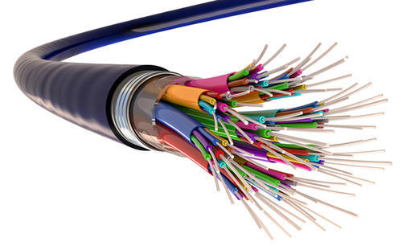

*OPTIC FIBRE CABLE*

Features

* High speed – There is a high velocity at which the signal is transmitted.
* Secure – The data being transmitted is more secured.
* Used for shorter distances
* Lightweight
* Increased capacity and bandwidth.

Limitations

* Length of the conductor that transmits the signals – Sometimes, the cables that are used for transmitting would be too much or too less based on the size of the conductor and that would affect the accuracy of the signals that are transmitted.
* Installation costs – It can be expensive and cost a lot of money to install or fit physical cables for transmitting signals from one communicating device to another.
* Maintenance – For all of this to run smoothly and properly, it would be necessary to maintain all of this and hence there would be work required for maintaining all of this.

***Unguided media***

Unguided media does not require any physical medium to transmit the electromagnetic signals. The signals travel through the air or sometimes even water. This media can also be called as wireless communication or unbounded transmission media as it does not have any border limitation. It cannot provide any direction for travelling. The signals are only available to those who have the device capable of receiving the signal. An advantage of the unguided media is such that it allows the user to connect all the time and since there is wireless communication, this enables the user to connect himself from anywhere to the network. The different types of unguided media are –

* Radio waves = Low frequency signals that are generated easily and can travel a long distance. It can also penetrate through buildings and the sending and receiving antennas need not be aligned. These frequencies range from 3Khz to 1GHz and are used in radios and cordless phones for transmission.
* Microwaves = These signals are transmitted in a straight line and therefore require LOS (line of sight) transmission. The distance that the signals travel depends on the height of the 2 antennas. Taller the length of the antennas, greater will be the distance covered by the signal. These waves also have frequencies that are higher than radio waves and are used in telephone communication in mobile phones, television distribution and the like. It ranges from 1GHz to 300GHz.
* Infrared waves = These waves are used for short range communication and cannot penetrate through obstacles which then prevents interference between systems. A government licence is not required for operating with these signals as it is more secure than eavesdropping. It ranges from 300Ghz to 400Thz. The waves are used in devices such as TV remotes, wireless mouses, keyboards, printers and the like.

--------------------------------------------------------------------------------------------------------------------------------------

**References**

<https://techdifferences.com/difference-between-guided-and-unguided-media.html>

<https://www.geeksforgeeks.org/types-transmission-media/>

--------------------------------------------------------------------------------------------------------------------------------------